Warehouse Inventory & Traceability Management System
Purpose
A full-stack web application to manage warehouse inventory, track movement, and solve supplier-to-customer traceability so every sold part can be traced back to its original supplier.
Tech Stack:
- Backend: Laravel PHP
- Frontend: React.js
- Database: MySQL/PostgreSQL
- API: RESTful API (Laravel)

Core Problems This System Solves
❌ Current Problem
Company cannot track:
Which supplier provided the exact part that was sold to a customer
✅ System Solution
This system introduces:
🔁 Traceability Chain
Supplier → Purchase Order → Goods Received → Inventory Batch → Sales Transaction → Customer
Each part/product unit is linked to:
- Supplier
- Purchase batch
- Storage location
- Sales record
- Customer

This enables full backward tracing:
Customer Sale → Inventory Batch → Supplier → Purchase Record

Core Modules
1. Product Management
- Product master data
- SKU / Part Number
- Category
- Unit of measurement
- Minimum stock level
- Barcode / QR support
2. Parts Management
Specialized inventory for parts:
- Serial numbers (optional)
- Batch numbers
- Expiry date (if applicable)
- Warranty period
- Compatibility tags
3. Supplier Management
- Supplier profile
- Contact persons
- Supplied categories
- Contract terms
- Performance metrics
- Quality rating
4. Customer Management
- Customer profiles
- Purchase history
- Warranty tracking
- Complaint history
5. Inventory Management
- Real-time stock levels
- Warehouse locations
- Bin/shelf tracking
- Multi-warehouse support (future)
6. Inventory Movement Tracking
All movements recorded:
- Stock In (Purchase)
- Stock Out (Sales)
- Transfer
- Returns
- Adjustments
- Damaged goods
7. Transaction System
Purchase Flow:
Supplier → Purchase Order → Goods Receipt → Inventory Batch Created
Sales Flow:
Customer Order → Inventory Allocation → Stock Out → Transaction Record

Supplier Traceability Architecture (CORE FEATURE)
Data Flow
Purchase:
Supplier
↓
Purchase Order
↓
Goods Receipt Note (GRN)
↓
Inventory Batch
Sale:
Inventory Batch
↓
Sales Transaction
↓
Customer
Trace Query Example:
Which supplier provided the part sold to Customer X on Invoice #INV1023?
System path:
Invoice → Sales_Items → Inventory_Batch → Purchase_Order → Supplier

Database Conceptual Model
Core Tables
- suppliers
- customers
- products
- parts
- purchase_orders
- purchase_items
- goods_receipts
- inventory_batches
- inventory
- sales_orders
- sales_items
- inventory_movements
- warehouses
- locations

Key Tables Structure
inventory_batches
id
product_id
supplier_id
purchase_order_id
batch_number
quantity_received
quantity_remaining
cost_price
received_date
warehouse_id
sales_items
id
sales_order_id
product_id
inventory_batch_id <-- CRITICAL LINK
quantity
selling_price
This inventory_batch_id is what enables supplier traceability.

Functional Features
Inventory
- FIFO / LIFO batch selection
- Expiry-based selling
- Low-stock alerts
- Auto reorder suggestions
Reporting
- Supplier performance
- Defective rate per supplier
- Inventory aging
- Dead stock
- Fast moving items
Traceability Reports
- Customer → Supplier trace
- Supplier → Customer trace
- Batch recall report
Filtering
- By supplier
- By customer
- By date
- By batch
- By part number
- By warehouse
Exporting
- Excel export
- CSV export
- PDF reports

System Roles
- Admin
- Warehouse Manager
- Storekeeper
- Procurement Officer
- Sales Staff
- Auditor

Laravel Backend Architecture
Structure
- API-first architecture
- JWT authentication
- Role-based access control
Modules
- AuthService
- InventoryService
- SupplierService
- TraceabilityService
- ReportingService
- ExportService

React Frontend Architecture
Pages
- Dashboard
- Inventory
- Parts
- Suppliers
- Customers
- Purchases
- Sales
- Reports
- Traceability Explorer

Traceability Explorer (Special Feature)
UI Flow
Search by:
- Invoice Number
- Customer Name
- Part Number
- Batch Number
Result:
Customer → Sale → Batch → Purchase → Supplier
Visual flow diagram in UI.

API Design Example
Trace Endpoint
GET /api/trace/sale/{sale_id}
Response:
{
"customer": {},
"sale": {},
"product": {},
"batch": {},
"supplier": {},
"purchase_order": {}
}

Excel Export Features
- Inventory list
- Stock movement
- Supplier sales mapping
- Customer purchase history
- Batch traceability

Development Phases
Phase 1: Core System
- Auth
- Products
- Suppliers
- Customers
- Inventory
- Purchases
- Sales
Phase 2: Traceability
- Batch tracking
- Supplier mapping
- Trace explorer
Phase 3: Intelligence
- Reports
- Analytics
- Alerts
- Optimization
Phase 4: Automation
- Auto reorder
- Supplier scoring
- Predictive stock

Why Laravel + React is Perfect
Laravel:
- ORM (Eloquent)
- Queue jobs
- Events
- Notifications
- Export tools
- API resources
React:
- Dynamic UI
- Dashboard
- Real-time updates
- Filtering
- Reporting
- Visualization

System Outcome
This system will give you:
✅ Full supplier traceability
✅ Batch-level inventory
✅ Legal-grade audit trail
✅ Recall management
✅ Quality control
✅ Operational transparency
✅ Cost optimization

Use Case Diagram
Actors (Simplified)
1. Admin
- Full system access
- Manages users and roles
- Performs all operational tasks
2. User
- Performs all operational tasks
- Cannot manage users or system settings

Access Rule (Important)
Admin = User capabilities + User Management
This means:
- All use cases available to User are also available to Admin
- Only Admin can manage users and system configuration

Core Use Cases
Authentication
- Login
- Logout
Product & Parts Management
- Create / Update Product
- Create / Update Part
- View Products & Parts
Supplier Management
- Add Supplier
- Update Supplier Details
- View Supplier History
Customer Management
- Add Customer
- Update Customer Details
- View Customer Purchase History
Purchase & Stock In
- Create Purchase Order
- Record Goods Receipt (GRN)
- Create Inventory Batch
- Record Stock In Movement
Inventory Management
- View Stock Levels
- Track Inventory by Batch
- Adjust Inventory
- View Inventory Movement History
Sales & Stock Out
- Create Sales Order
- Allocate Inventory (FIFO/LIFO)
- Record Stock Out Movement
- Generate Invoice
Traceability (KEY FEATURE)
- Trace Sale to Supplier
- Trace Supplier to Customers
- Trace Batch History
Reporting & Export
- Generate Inventory Report
- Generate Supplier Report
- Generate Sales Report
- Export Data to Excel / CSV
Admin-Only Use Cases
- Create User
- Update User
- Deactivate User
- Assign Roles & Permissions

Use Case Diagram (Textual Representation)
+----------------+
| Admin |
+----------------+
|
| (inherits all User use cases)
|
+----------------+
| User |
+----------------+
| | | |
| | | |
-----------------------------------------------------
| Products | Inventory | Purchases | Sales | Reports |
-----------------------------------------------------
| | | |

Admin-only:
-----------------------
| Manage Users |
| Assign Permissions |
-----------------------

------------------+
| Admin |
+---------------------+
| | | |
| | | |
| Manage Users | System Settings | All Reports |
+----------------+ +-------------------+
| Procurement | | Warehouse Manager |
| Officer | +-------------------+
+----------------+
| | | | | |
| | | | | |
| | | ---------------------------------
| | | | Inventory | Traceability | Reports |
| | | ---------------------------------

| Purchase Order |
| Goods Receipt |
| Supplier Management |
+---------------+ +---------------+
| Storekeeper | | Sales Staff |
+---------------+ +---------------+
| | | | | |
| | | | | |

| Stock In | | Sales Order |
| Batch Creation | | Inventory Allocation |
| Stock Transfer | | Stock Out |

+------------------+
| Auditor / Mgmt |
+------------------+
|
| View Reports |
| Trace Supplier ↔ Customer |

---

## Key Use Case Relationships

### Include Relationships
- "Record Goods Receipt" → includes → "Create Inventory Batch"
- "Create Sales Order" → includes → "Allocate Inventory"
- "Allocate Inventory" → includes → "Record Stock Out"

### Extend Relationships
- "Trace Sale to Supplier" extends "View Sales Transaction"
- "Generate Recall Report" extends "Trace Batch History"

---

## Why This Use Case Diagram Is Correct

- Separates responsibilities clearly
- Reflects real warehouse operations
- Supports audit & traceability
- Scales to multi-warehouse systems
- Matches Laravel role-based permissions

---

# Next Steps

1. ERD Diagram
2. Class Diagram
3. Database Schema (SQL)
4. API Endpoints
5. UI Wireframes
6. Auth & Roles Model

1. ERD Diagram
2. Use Case Diagram
3. Class Diagram
4. Database Schema (SQL)
5. API Contract
6. UI Wireframes
7. Auth & Role Model

---

## This is not just inventory management — it's a **traceability system**.

It transforms your company from:
> "We don't know where the part came from"

To:
> "We can trace every part from supplier to customer in 2 clicks"

Use Case Diagram
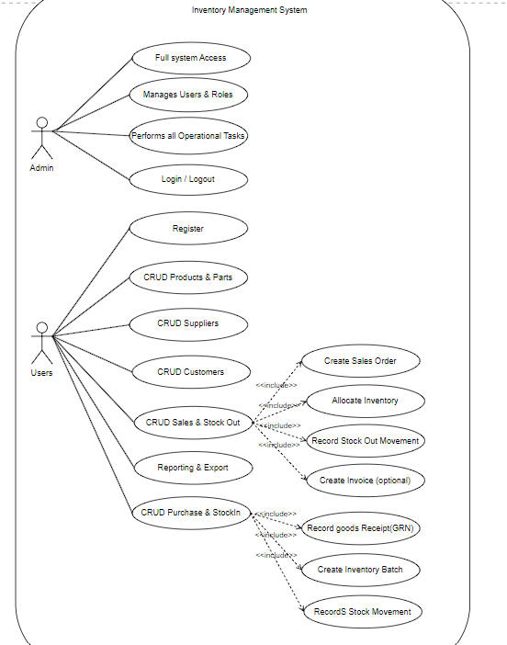

ERD diagram
